My First test script with JUNIT and Selenium

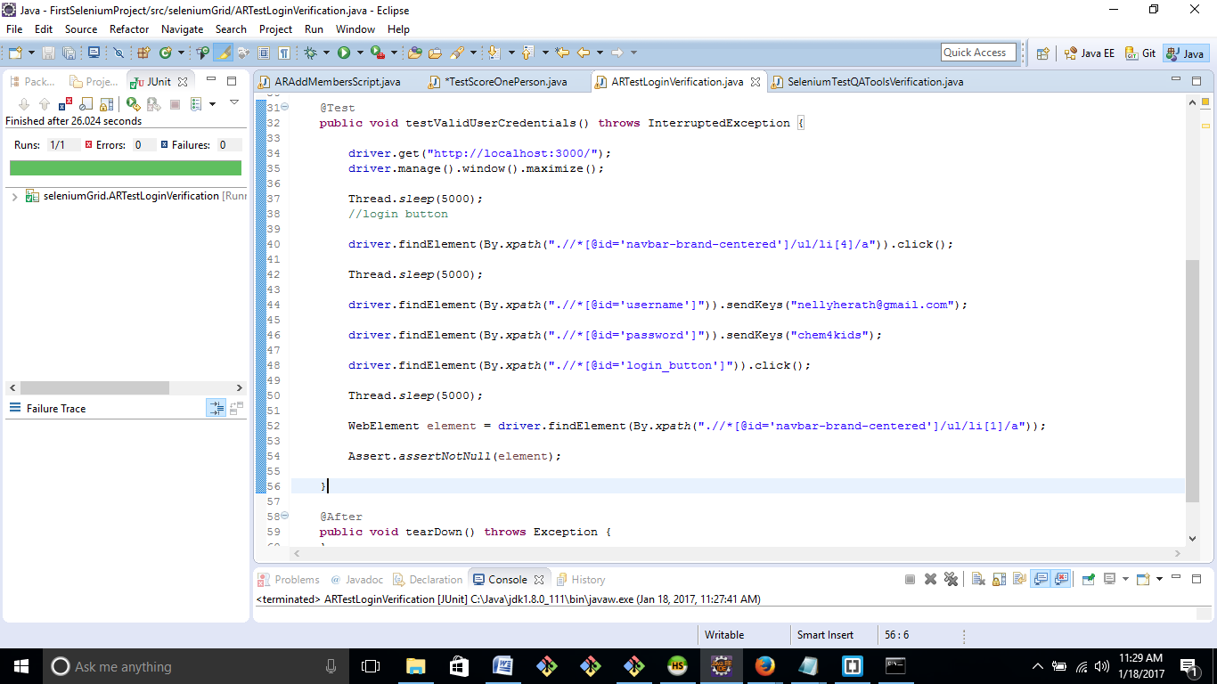

Cool eh?